Data sheet for frontend
A different frontend should only be visible on the monitor tab, and the additional tabs should still be available.
When no vehicle is selected, the tab will show a list of vehicles and then the rest of the screen will be filled out by the existing map.
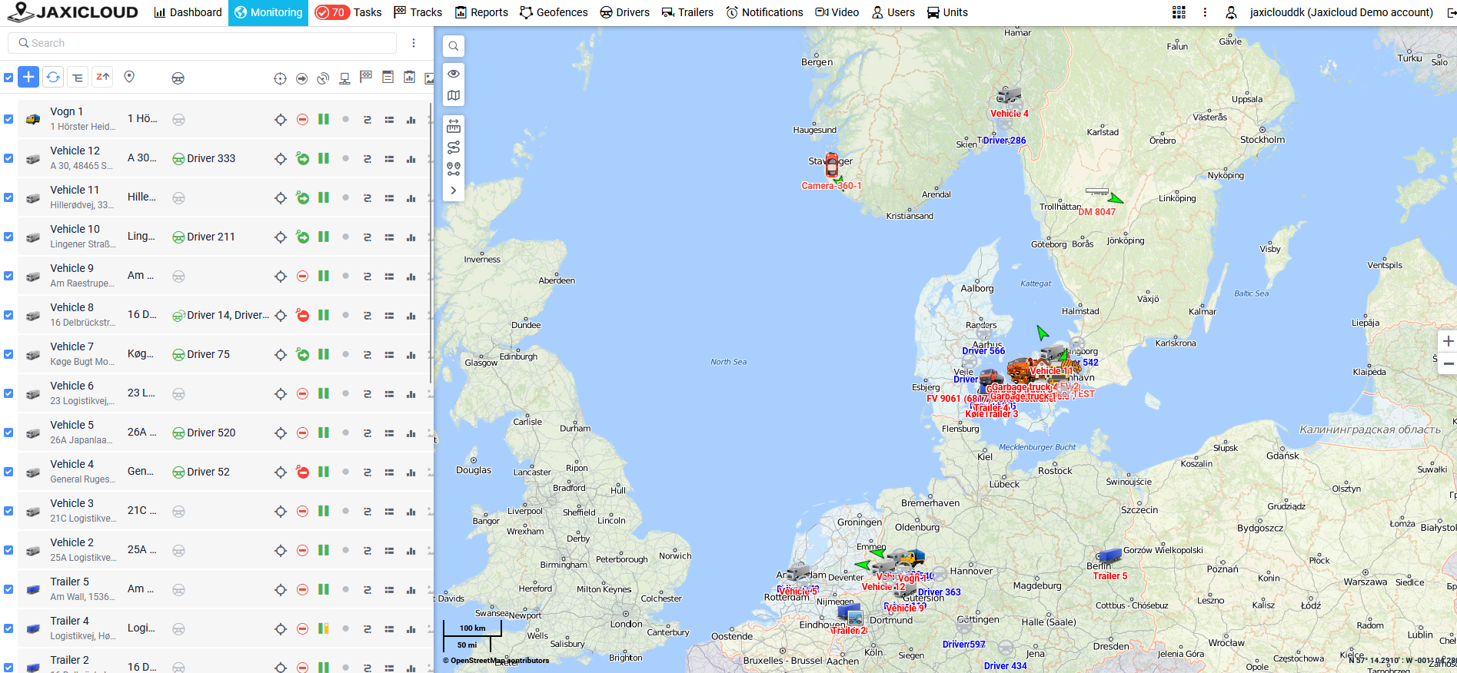
The above picture shows the existing view for our customers, and the front end will be the same, except the list of vehicles will be simplified as mentioned below.
Below tab selection but above vehicle list and map (see red marking on picture below)
A general overview of the fleet.
It should be possible to select which data is shown here.
It could be something like:
- Active vehicles
- Parked vehicles
- Number of drivers checked in
- Drivers on the road
- Drivers loading goods
- Drivers on a break
- Vehicles that need service this month
- Planned service
- Active alarms
- Fleet utilization (in percentage)
- Etc.
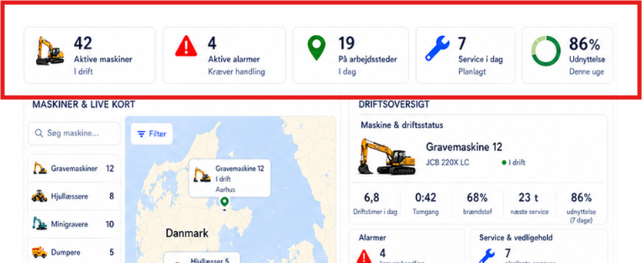

Left side:
List of vehicles and map.
Possible to choose between list of all vehicles or divided into groups
Both vehicles and groups are added by superuser and will continue to grow.
When selecting the specific group, a list of cars should emerge below.
When clicking a specific vehicle once, it should show on the map with a list of info (it could be something like ikon, name of vehicle, status, driver, etc) set by customer/superuser.
When clicking on a specific vehicle twice an overview should appear on the right side of the screen

Overview - Right side:
Display of different info selected by customer from a list - Appears when double clicked on vehicle from the list on the left side.
Here it is possible to select themes like location, driver behavior, vehicle profile, etc.
- Driver
  - Name
  - ID
  - Status (green driving, yellow loading/unloading/standby/service, red parked/pause)
  - Drivetime remaining
  - Next break
  - Daily driving time
  - 10h driving days
  - 9h rest period
  - Reduced weekly rest

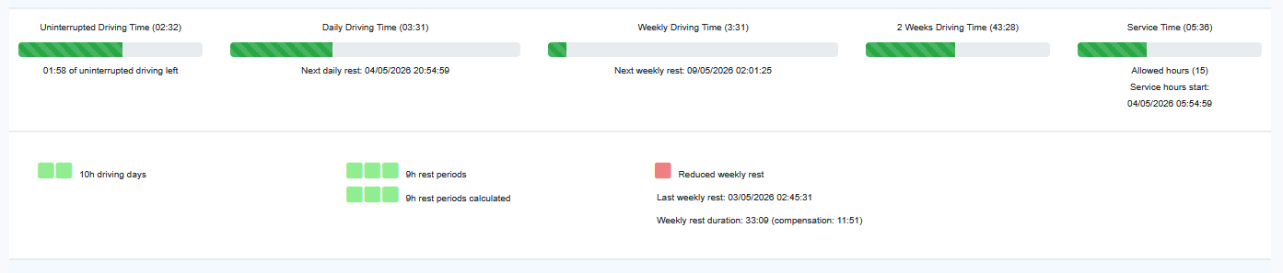
- Driver behavior
  - Health check (acceleration, break, turning)
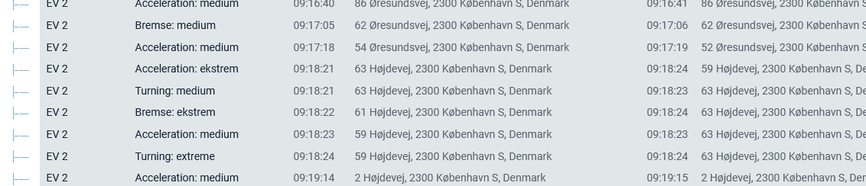
- Location
  - Address
  - Within Geofence
  - Number of trips
  - Number of kilometers driven today
  - Number of stops today
- Alarms
  - Active alarms
  - Latest events
  - Tasks today
- Vehicle
  - Operating hours today
  - Idling
  - Fuel level
  - Energy level
  - Mileage
  - Average speed
  - Max speed
  - Next service
  - Utilization
  - CO2 emission
  - Axle pressure
  - Reefer status (Temperature)
  - TPMS
- Service
  - Repairs needed
  - Date of next service
It must be possible to always add additional datapoints to the list that the customer is choosing from, as we constantly expand with new solutions.

